

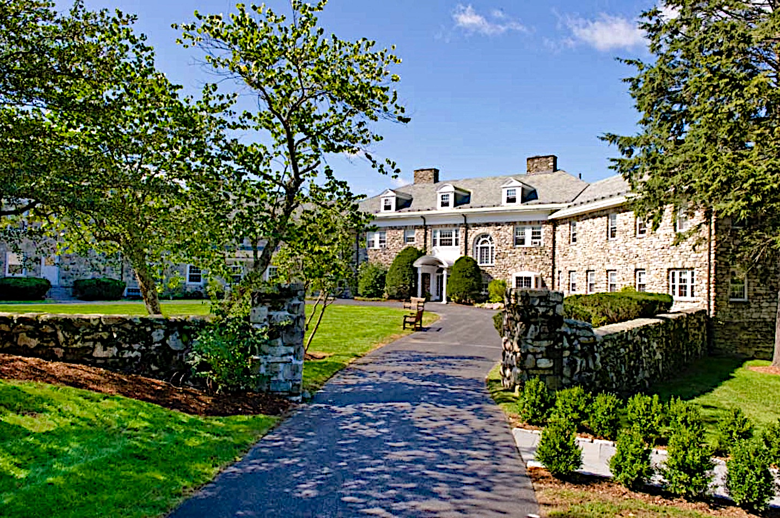
Thursday, April 3 to Sunday, April 6, 2025
Ignatian
Silent Retreat

Center for Ignatian Spirituality

